**Topics in SE**



**Assignment # 1**

|  |  |
| --- | --- |
| **Reg. #** | **Student Name** |
| FA19-BSE-080 | Muhammad Asad Saeed |
| FA19-BSE-028 | Muhammad Ahmad |
| FA19-BSE-100 | Awais Ali |
| FA19-BSE-096 | Asim Amir |

**A)**

**Options that discussed in lecture**

1. **Eclipse Marketplace**

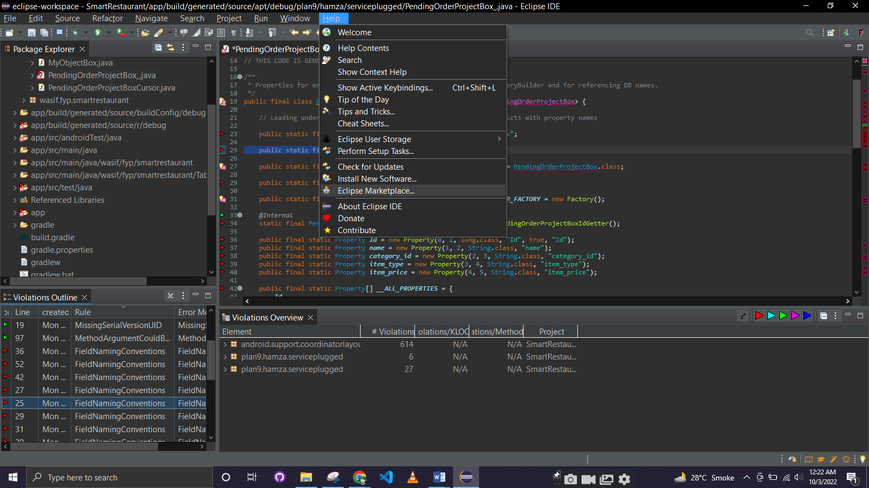

1. **PMD Installation:**

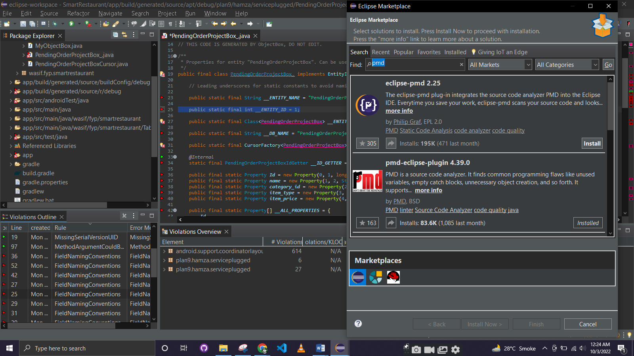

1. **Check Code**

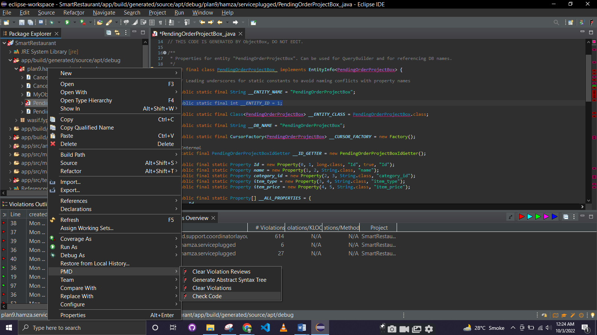

1. **Code analyze results**

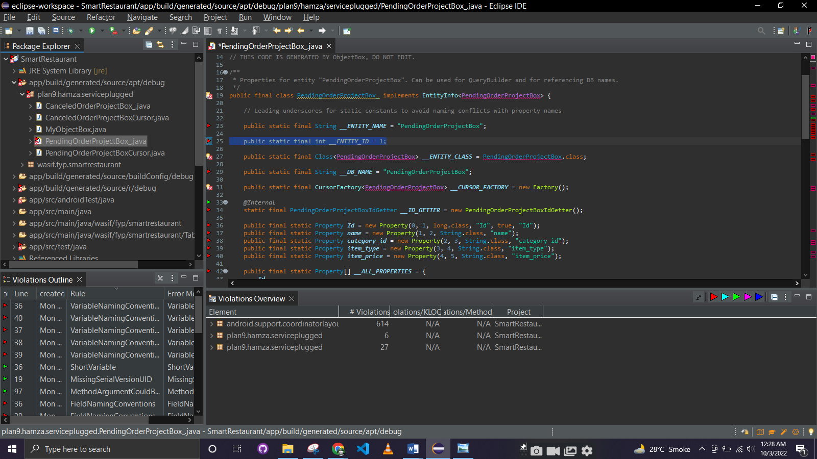

**B) Use PMD**

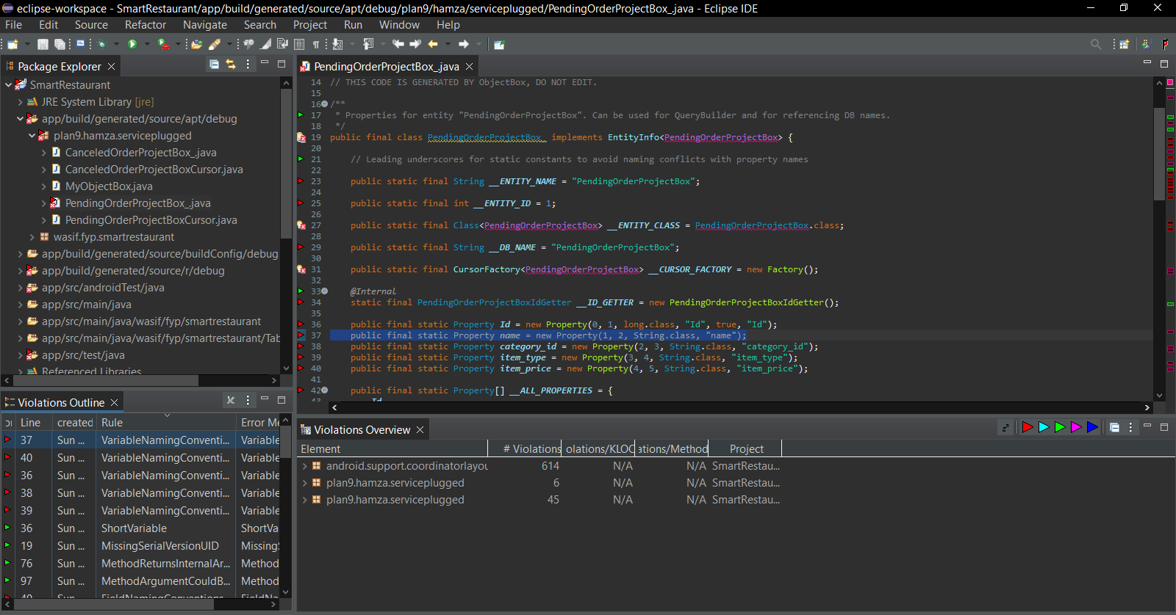

**Rules Discovered**

1. **VariableNamingConventions**
   1. **Variable that are static and final should be capitalized**

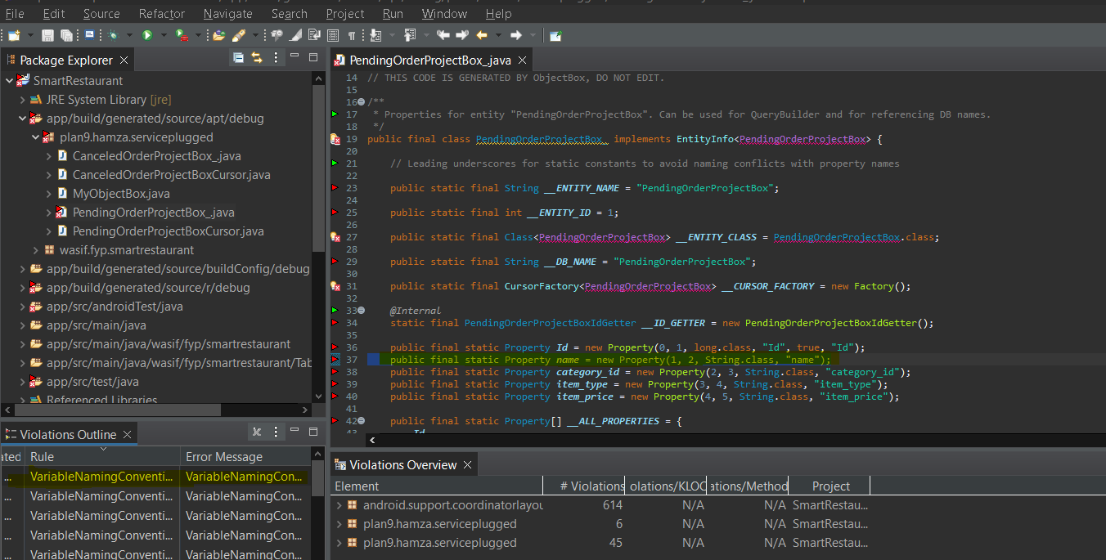

1. **Short Variable**

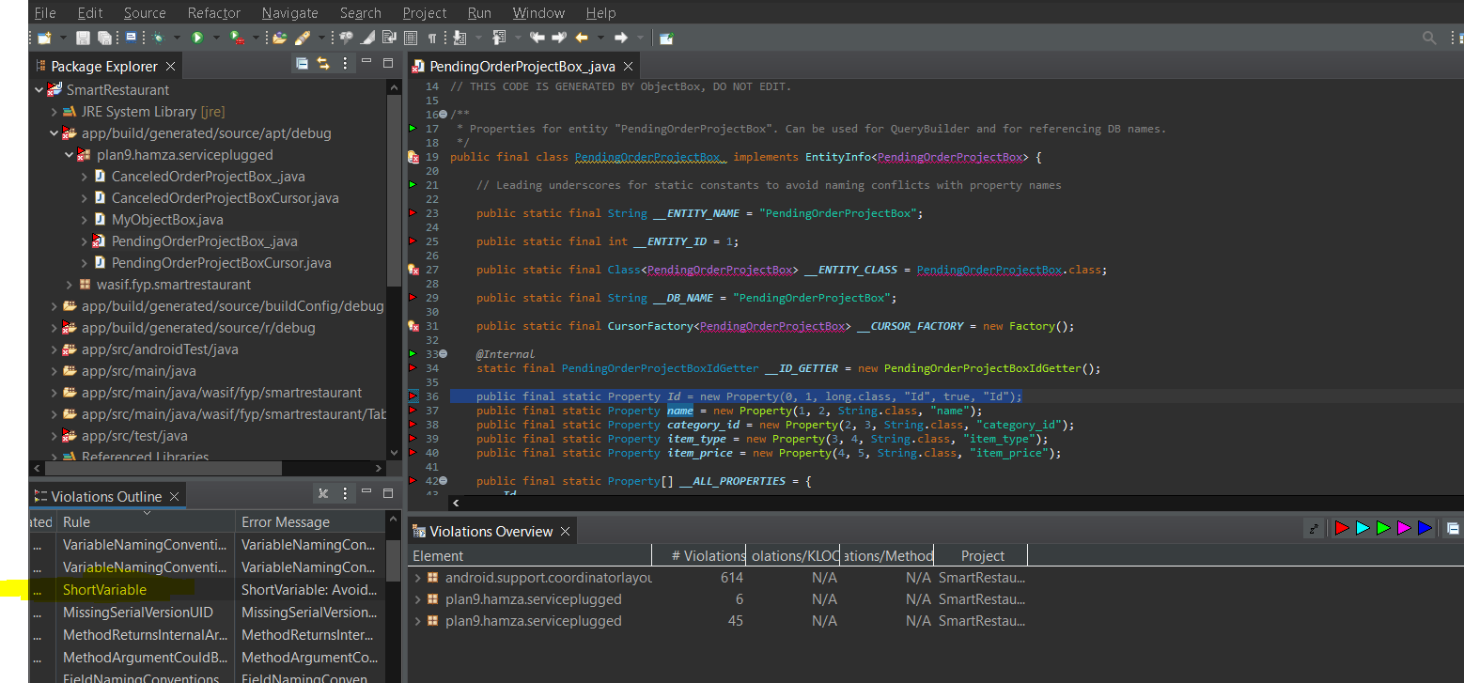

1. **Comment Size**
   1. **Comment line is too large**

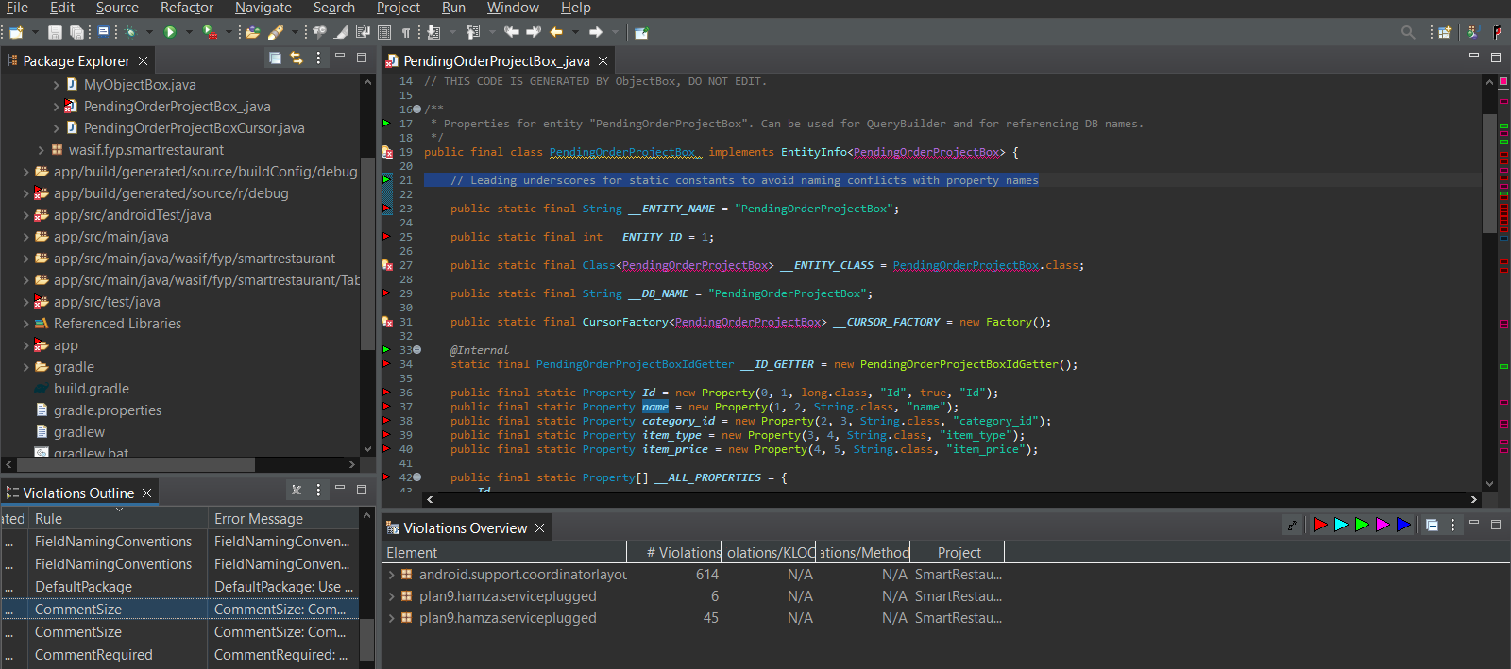

**C) Checkstyle**

**Rule No 1:**

Abbreviation in name 'DBConnection' must contain no more than '1' consecutive capital letters.

**Solution:**

We have change the class name from 'DBConnection' to 'DbConnection' on line 7 and line 20 and also change the class file name from 'DBConnection' to 'DbConnection' to remove this warning, also rename it in whole project.

**Rule No 2**

Multiple markers at this line

- 'method def modifier' has incorrect indentation level 4, expected level should be 2.

- WhitespaceAround: '{' is not preceded with whitespace.

- Missing a Javadoc comment.

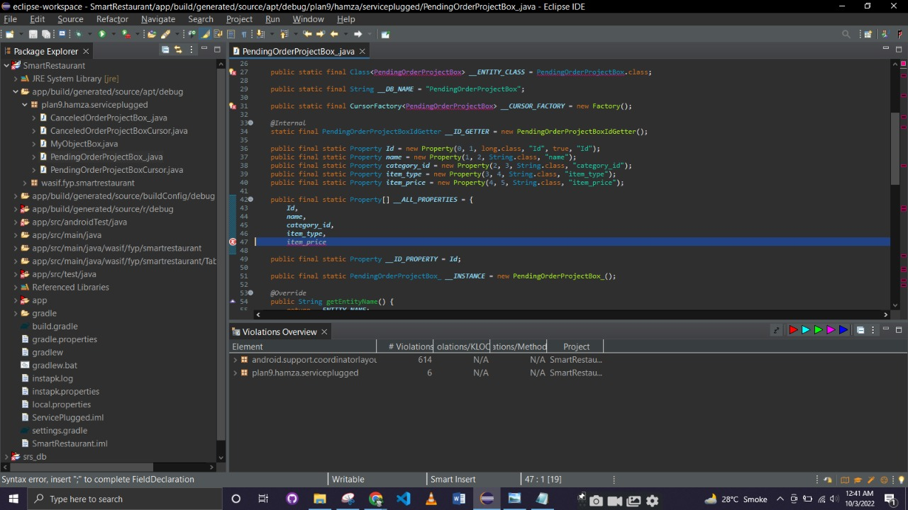

**Solution:**

1. By changeing the formatter settings or just removing two sapces.
2. By geving the white space before the curly brace.
3. By writing a comment.